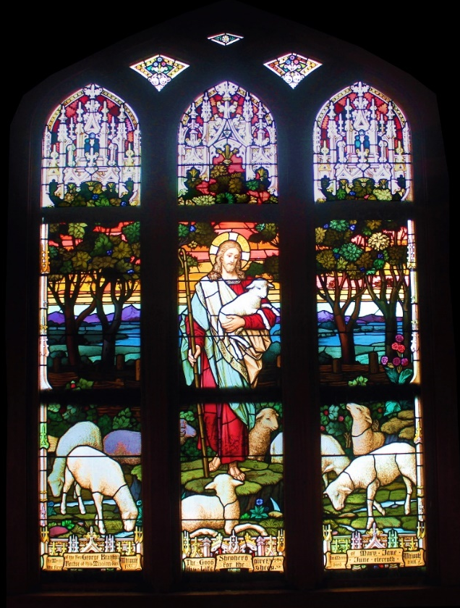
Good Shepherd Episcopal Church
Invites you to
Homecoming Sunday
February 26, 2017
All are invited
Eucharist at 9:00am
The Right Reverend Bishop Robert Fitzpatrick will be present
Finale Celebration of our Sesquicentennial Year
150 years in Wailuku at the same site
Festivities and entertainment to follow

2140 Main Street, Wailuku, HI 96793 808-244-4656

