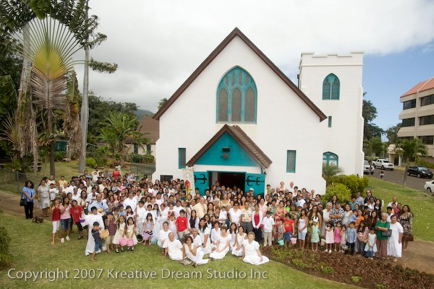
The Church of the Good Shepherd – Wailuku
PASTORAL CARE REQUEST
___ Visit from Priest ___ Hospital Visit ___ Home Visit
___ Contact me for: ________________________________
___ Prayers for: ________________________________
I am interested in information:
___ Volunteering ___ Baptism ___ Ohana Kitchen
___ Donating ___ Confirmation ___ Bible Studies
___ Choir ___ Other: __________________________
Print Your Name: _____________________________________
Contact# or email: _____________________________________
(Please place in offering plate
or e-mail to marvinleefoltz @ gmial.com or office@goodshepherdmaui.org)

“We live, give, and share God’s love”

